Conic Sections
# Source: AI Source: Provided by: [Data Path: Persons Table -> ID Column: 1, Name_En Column: Motasem Essam] -> From: [ChatGPT] on [7/25/2026]
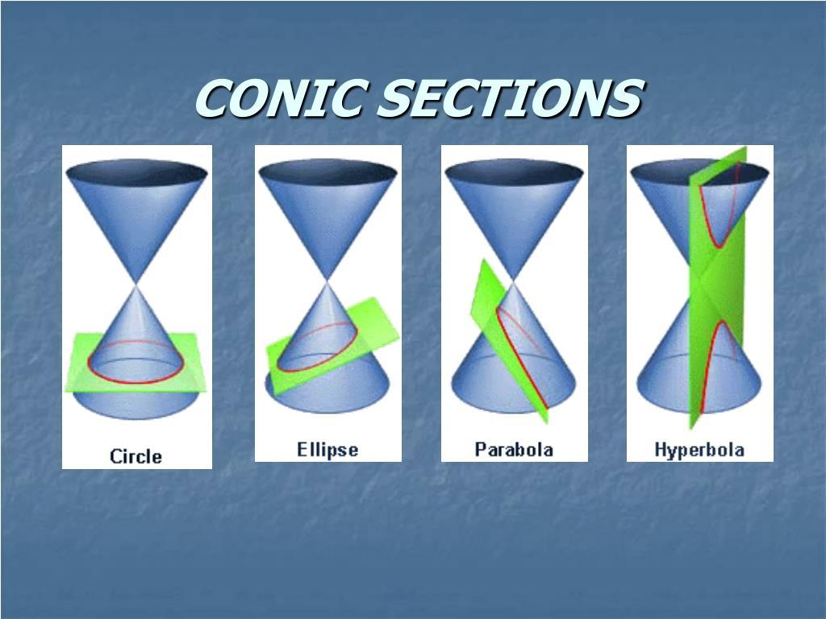
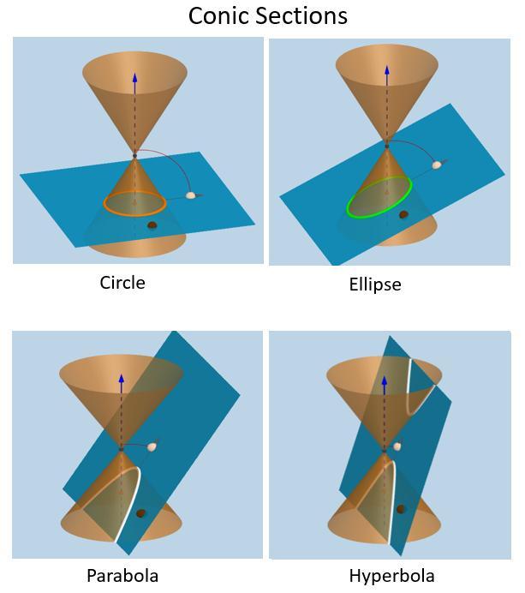
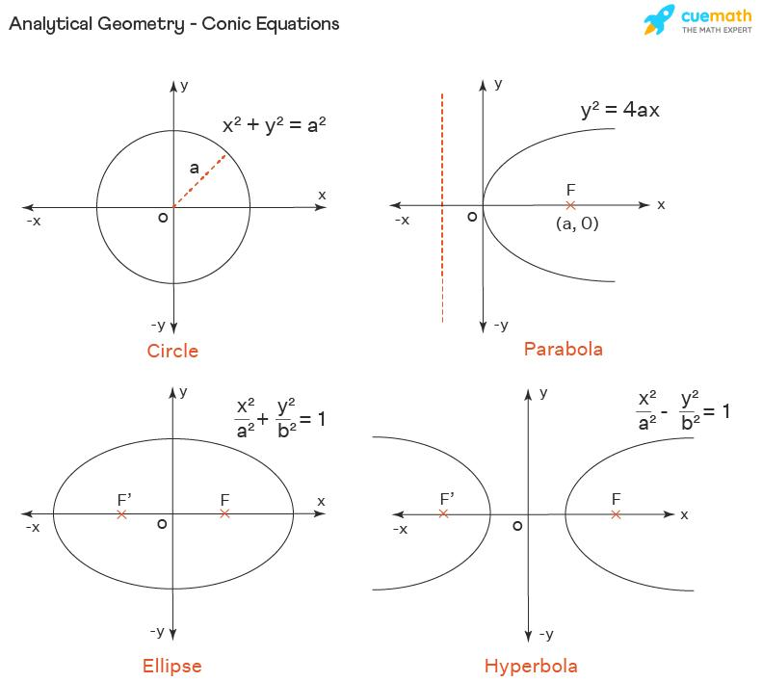
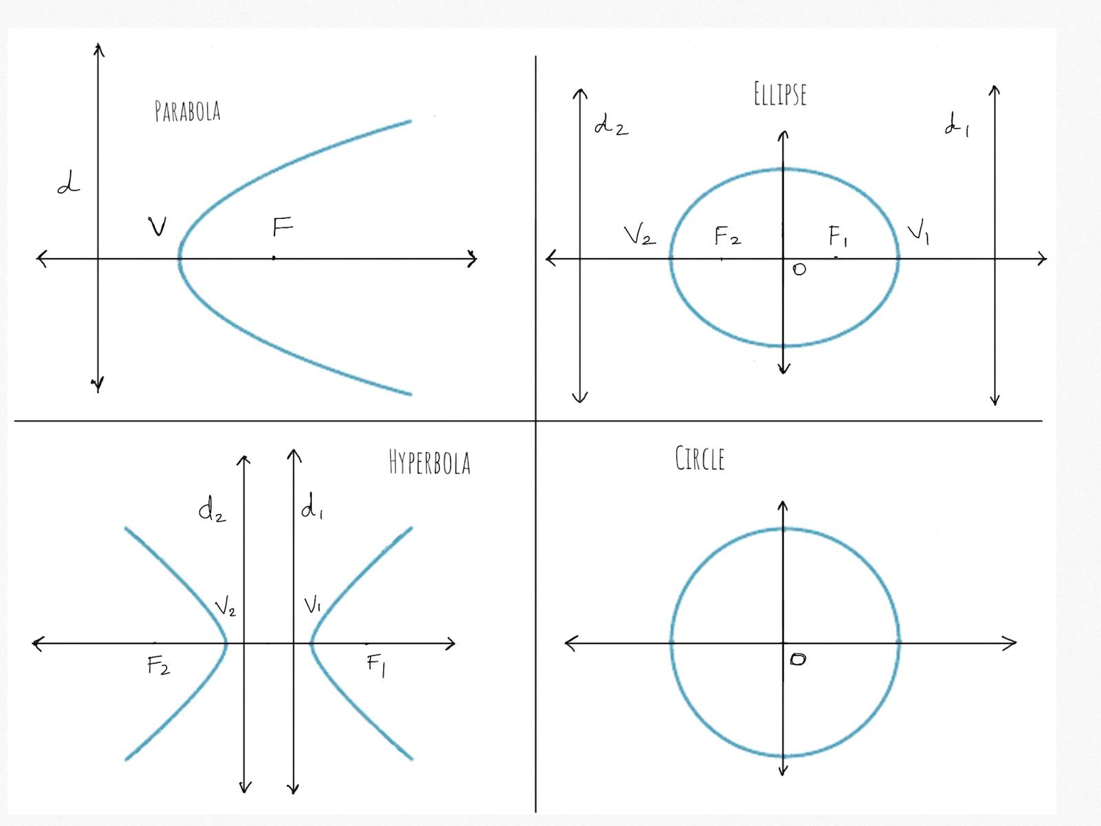
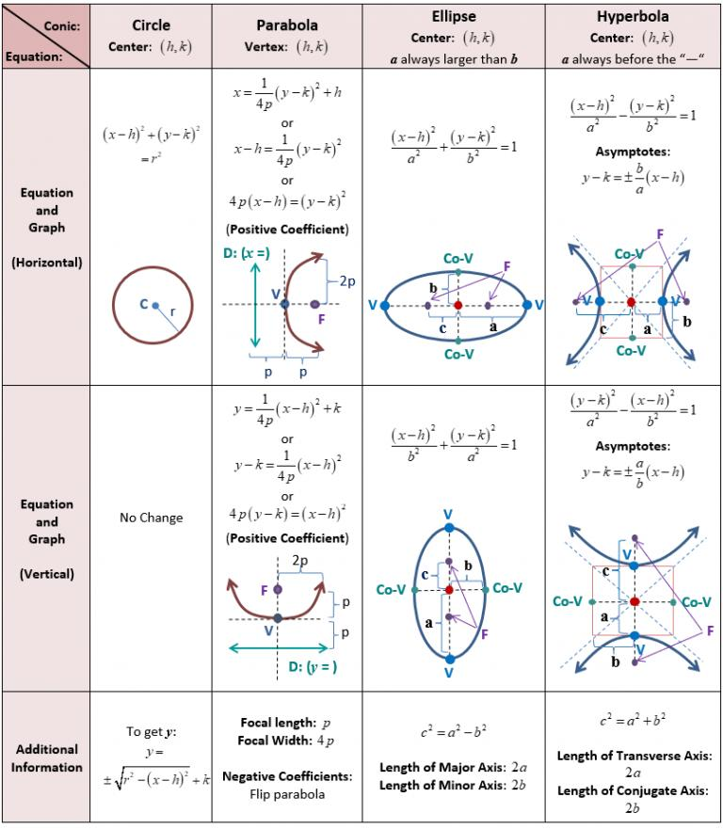

Definition
# Source: AI Source: Provided by: [Data Path: Persons Table -> ID Column: 1, Name_En Column: Motasem Essam] -> From: [ChatGPT] on [7/25/2026]
Conic sections are curves obtained by intersecting a double cone with a plane.
Depending on the angle and position of the cutting plane, the intersection produces one of four fundamental conic sections:
- Circle
- Ellipse
- Parabola
- Hyperbola
They are important objects in Euclidean geometry, analytic geometry, algebra, physics, and engineering.

Fundamental Concept
# Source: AI Source: Provided by: [Data Path: Persons Table -> ID Column: 1, Name_En Column: Motasem Essam] -> From: [ChatGPT] on [7/25/2026]
Imagine a double cone:
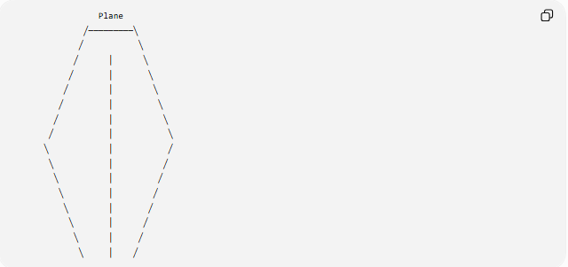
Plane
╱─────────╲
╱ ╲
╱ │ ╲
╱ │ ╲
╱ │ ╲
╱ │ ╲
╱ │ ╲
╱ │ ╲
╲ │ ╱
╲ │ ╱
╲ │ ╱
╲ │ ╱
╲ │ ╱
╲ │ ╱
╲ │ ╱
╲ │ ╱
The shape of the resulting curve depends on the orientation of the plane.

Classification
# Source: AI Source: Provided by: [Data Path: Persons Table -> ID Column: 1, Name_En Column: Motasem Essam] -> From: [ChatGPT] on [7/25/2026]
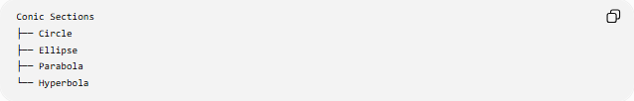
Conic Sections
├── Circle
├── Ellipse
├── Parabola
└── Hyperbola
These four are the non-degenerate conic sections.
There are also degenerate conics, which occur when the cutting plane passes through the vertex of the cone.
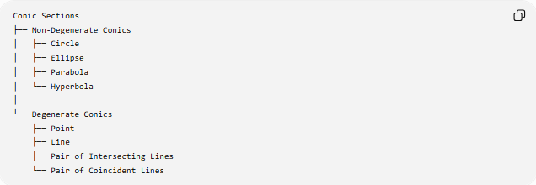
Conic Sections
├── Non-Degenerate Conics
│ ├── Circle
│ ├── Ellipse
│ ├── Parabola
│ └── Hyperbola
│
└── Degenerate Conics
├── Point
├── Line
├── Pair of Intersecting Lines
└── Pair of Coincident Lines

1. Circle
# Source: AI Source: Provided by: [Data Path: Persons Table -> ID Column: 1, Name_En Column: Motasem Essam] -> From: [ChatGPT] on [7/25/2026]
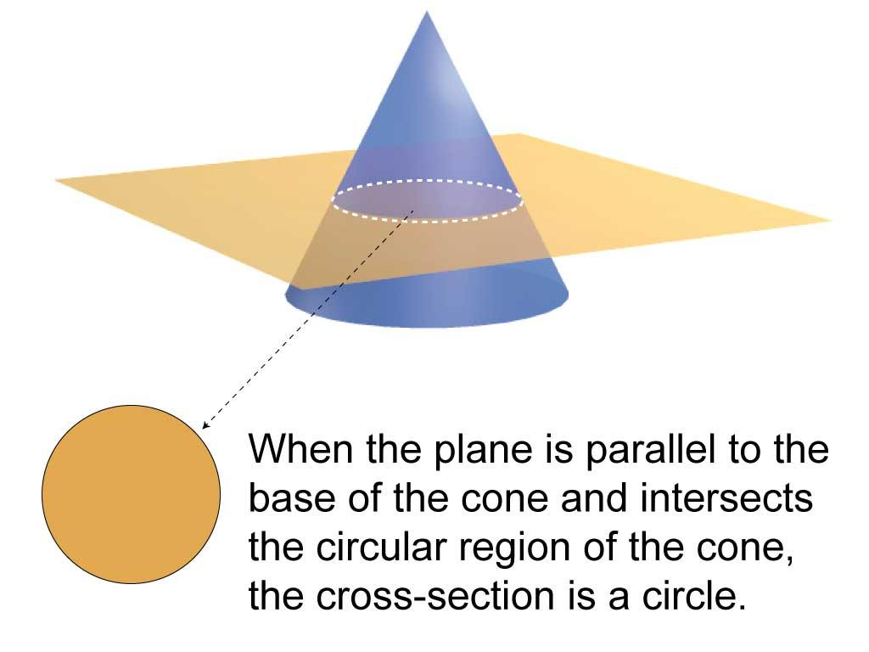
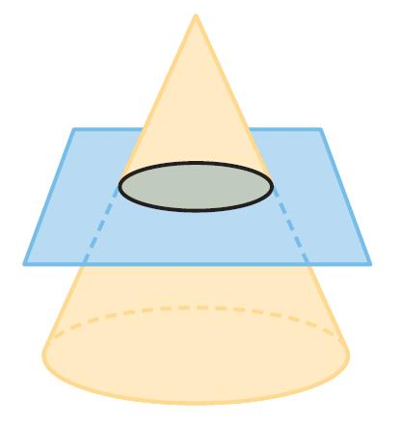
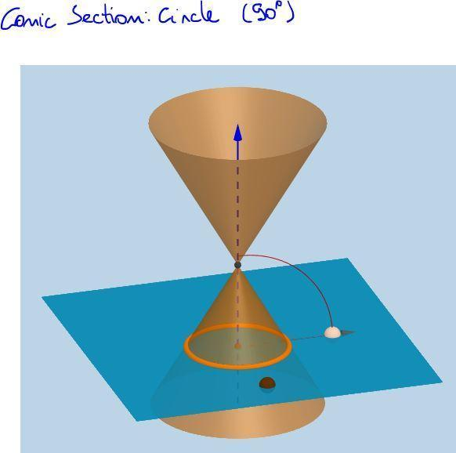
A circle is obtained when a plane cuts the cone perpendicular to its axis.
It can also be defined as the set of all points that are the same distance from a fixed point called the center.
Standard equation
$$\boxed{{\left(x-h\right)}^{2}+{\left(y-k\right)}^{2}=r^{2}}$$
where:
- $\left(h , k\right)$= center
- $r$= radius
Eccentricity
$$\boxed{e=0}$$

2. Ellipse
# Source: AI Source: Provided by: [Data Path: Persons Table -> ID Column: 1, Name_En Column: Motasem Essam] -> From: [ChatGPT] on [7/25/2026]
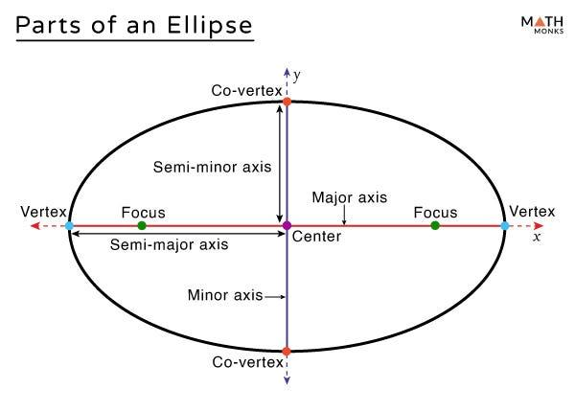
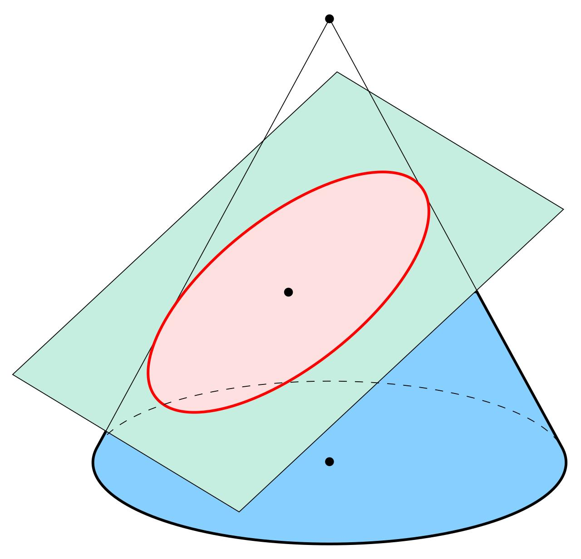
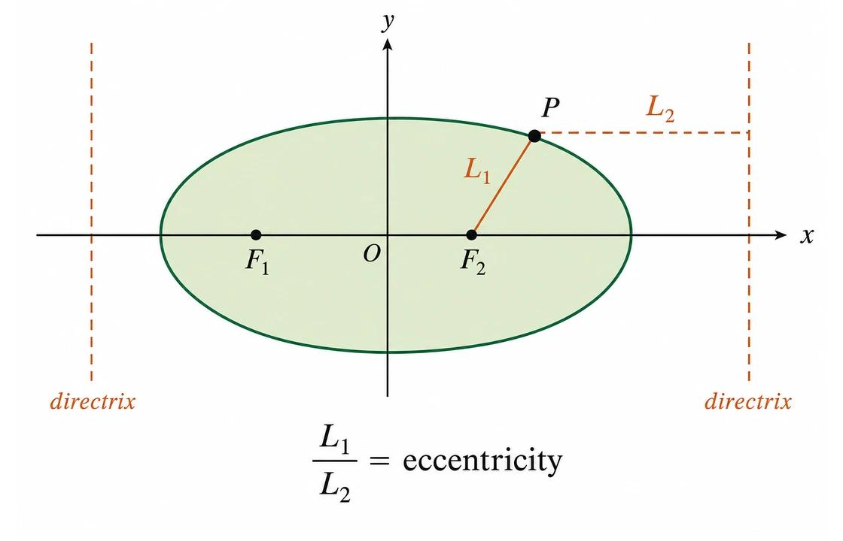
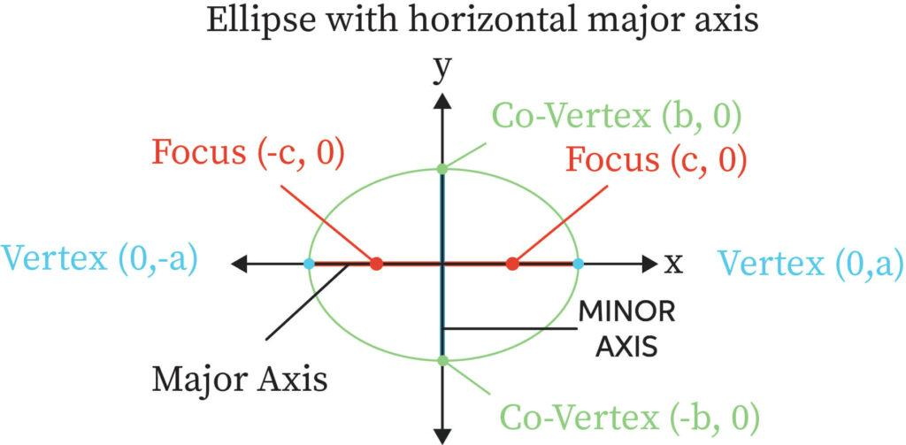
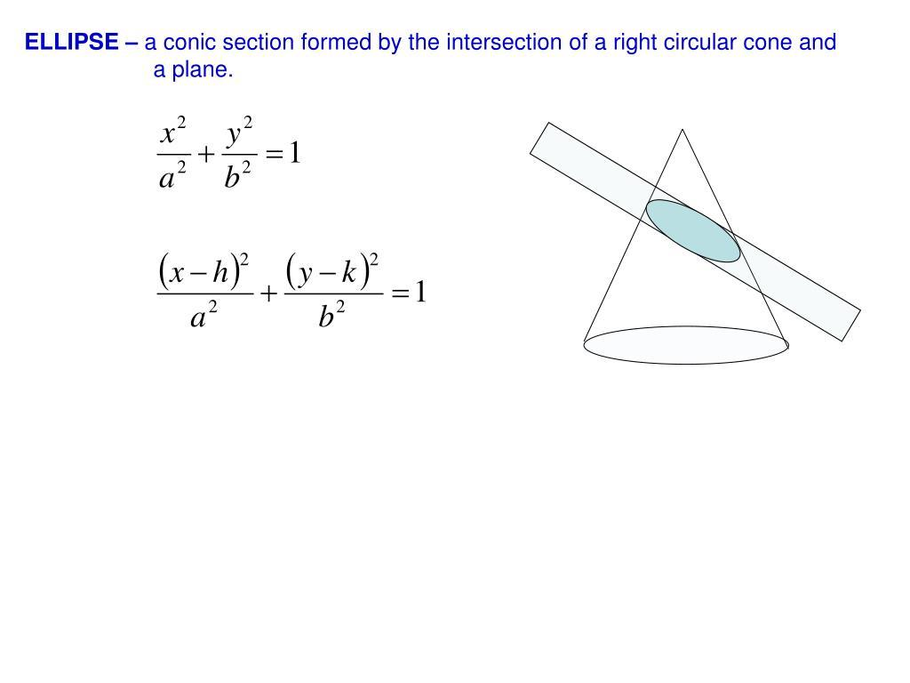
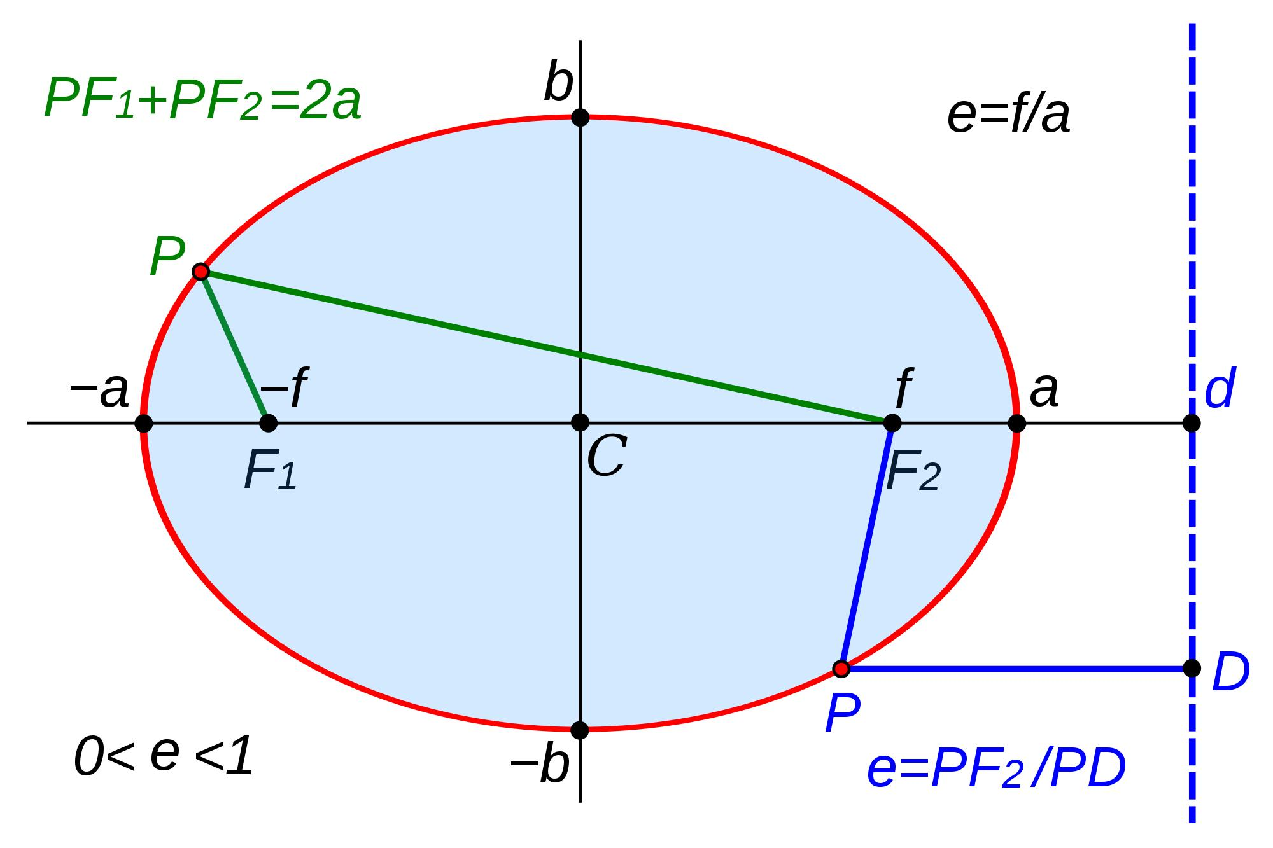
An ellipse is obtained when a plane cuts only one nappe of the cone at an angle that is not parallel to a generating line.
A circle is a special case of an ellipse.
An ellipse can be defined using two fixed points called foci: the sum of the distances from any point on the ellipse to the two foci is constant.
Standard equation
$$\boxed{\frac{{\left(x-h\right)}^{2}}{a^{2}}+\frac{{\left(y-k\right)}^{2}}{b^{2}}=1}$$
Eccentricity
$$\boxed{0<e<1}$$

3. Parabola
# Source: AI Source: Provided by: [Data Path: Persons Table -> ID Column: 1, Name_En Column: Motasem Essam] -> From: [ChatGPT] on [7/25/2026]
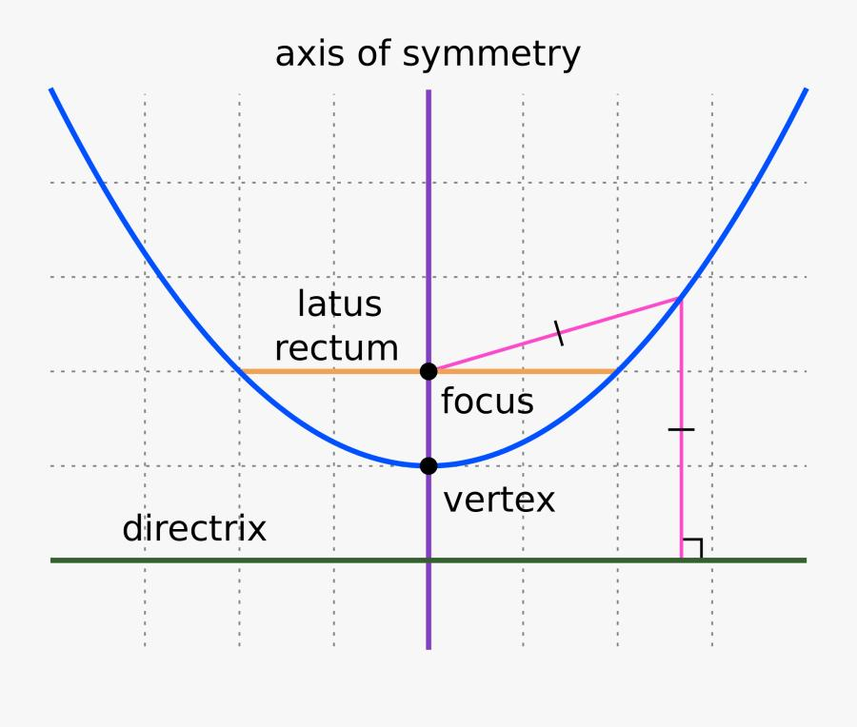
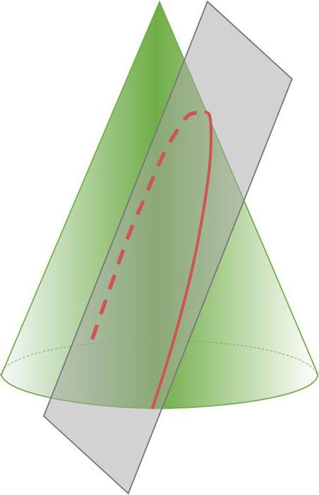
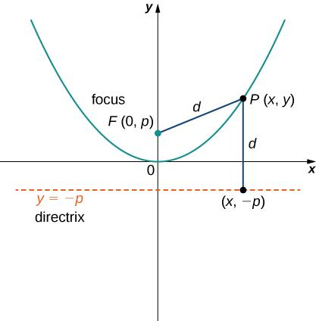
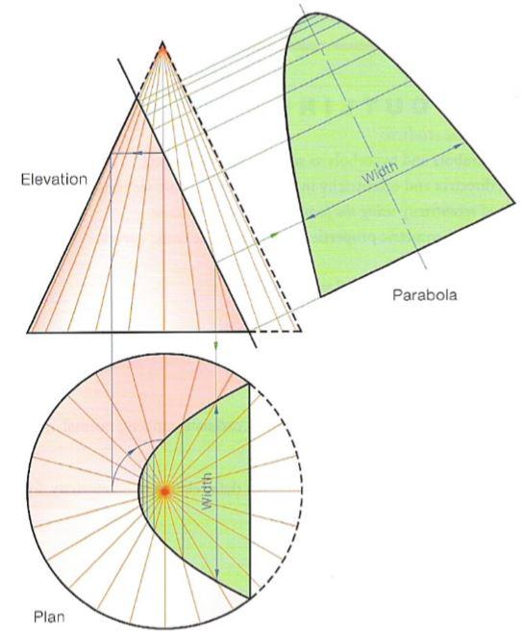
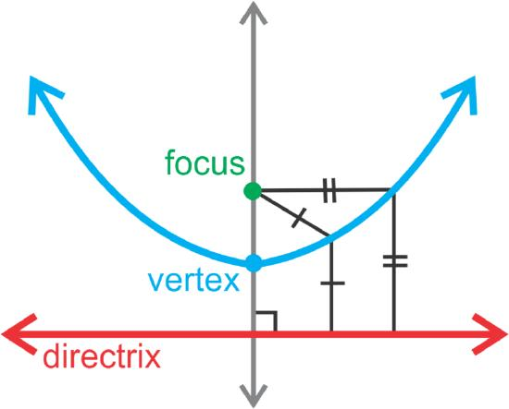
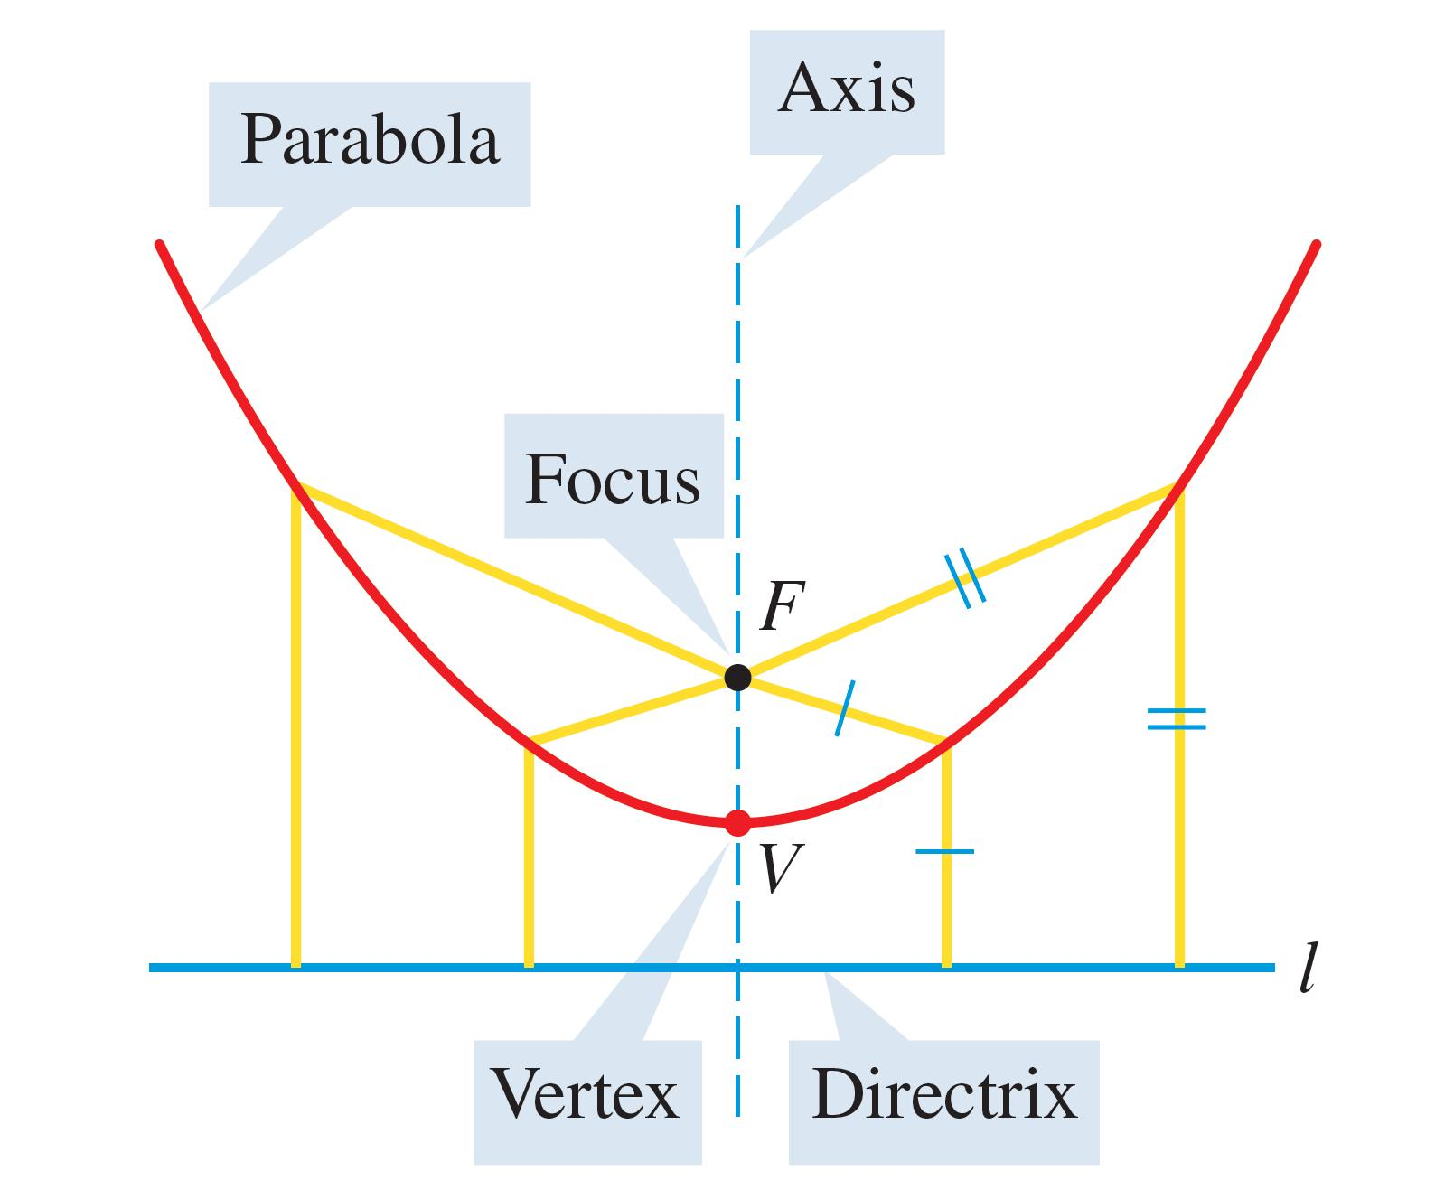
A parabola is obtained when the cutting plane is parallel to a generating line of the cone.
It can also be defined as the set of points that are equally distant from:
- a fixed point called the focus
- a fixed line called the directrix
Standard equation
For a vertically oriented parabola:
$$\boxed{{\left(x-h\right)}^{2}=4p\left(y-k\right)}$$
Eccentricity
$$\boxed{e=1}$$

4. Hyperbola
# Source: AI Source: Provided by: [Data Path: Persons Table -> ID Column: 1, Name_En Column: Motasem Essam] -> From: [ChatGPT] on [7/25/2026]
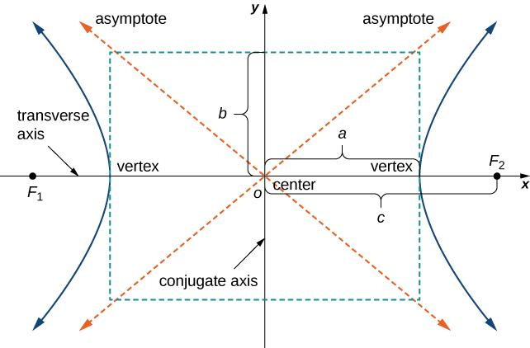
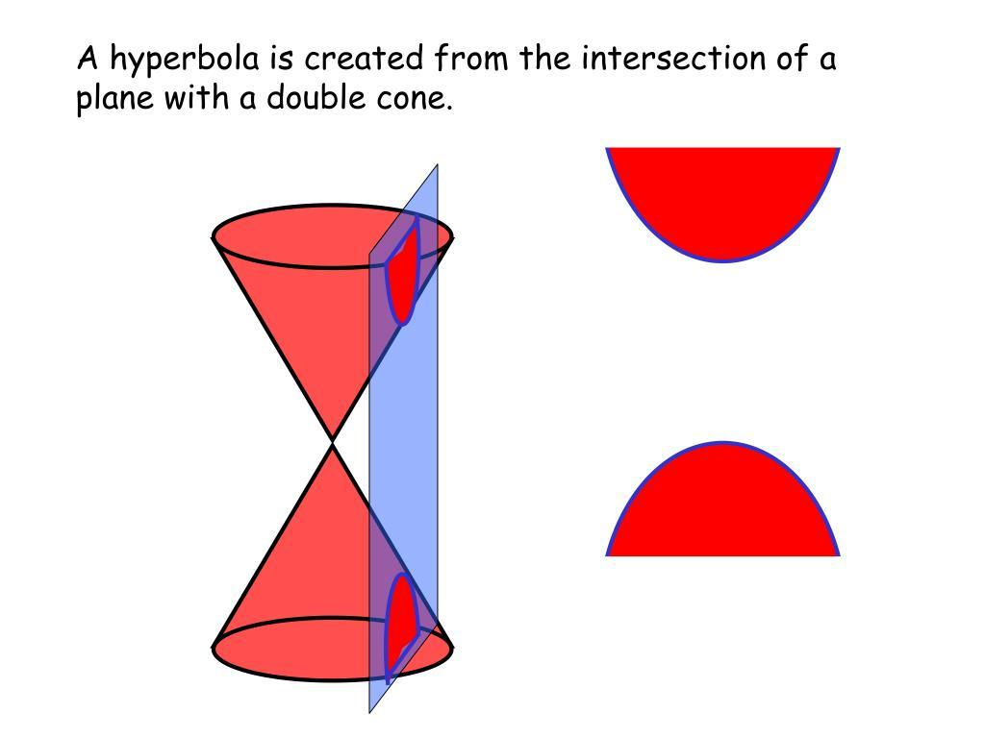
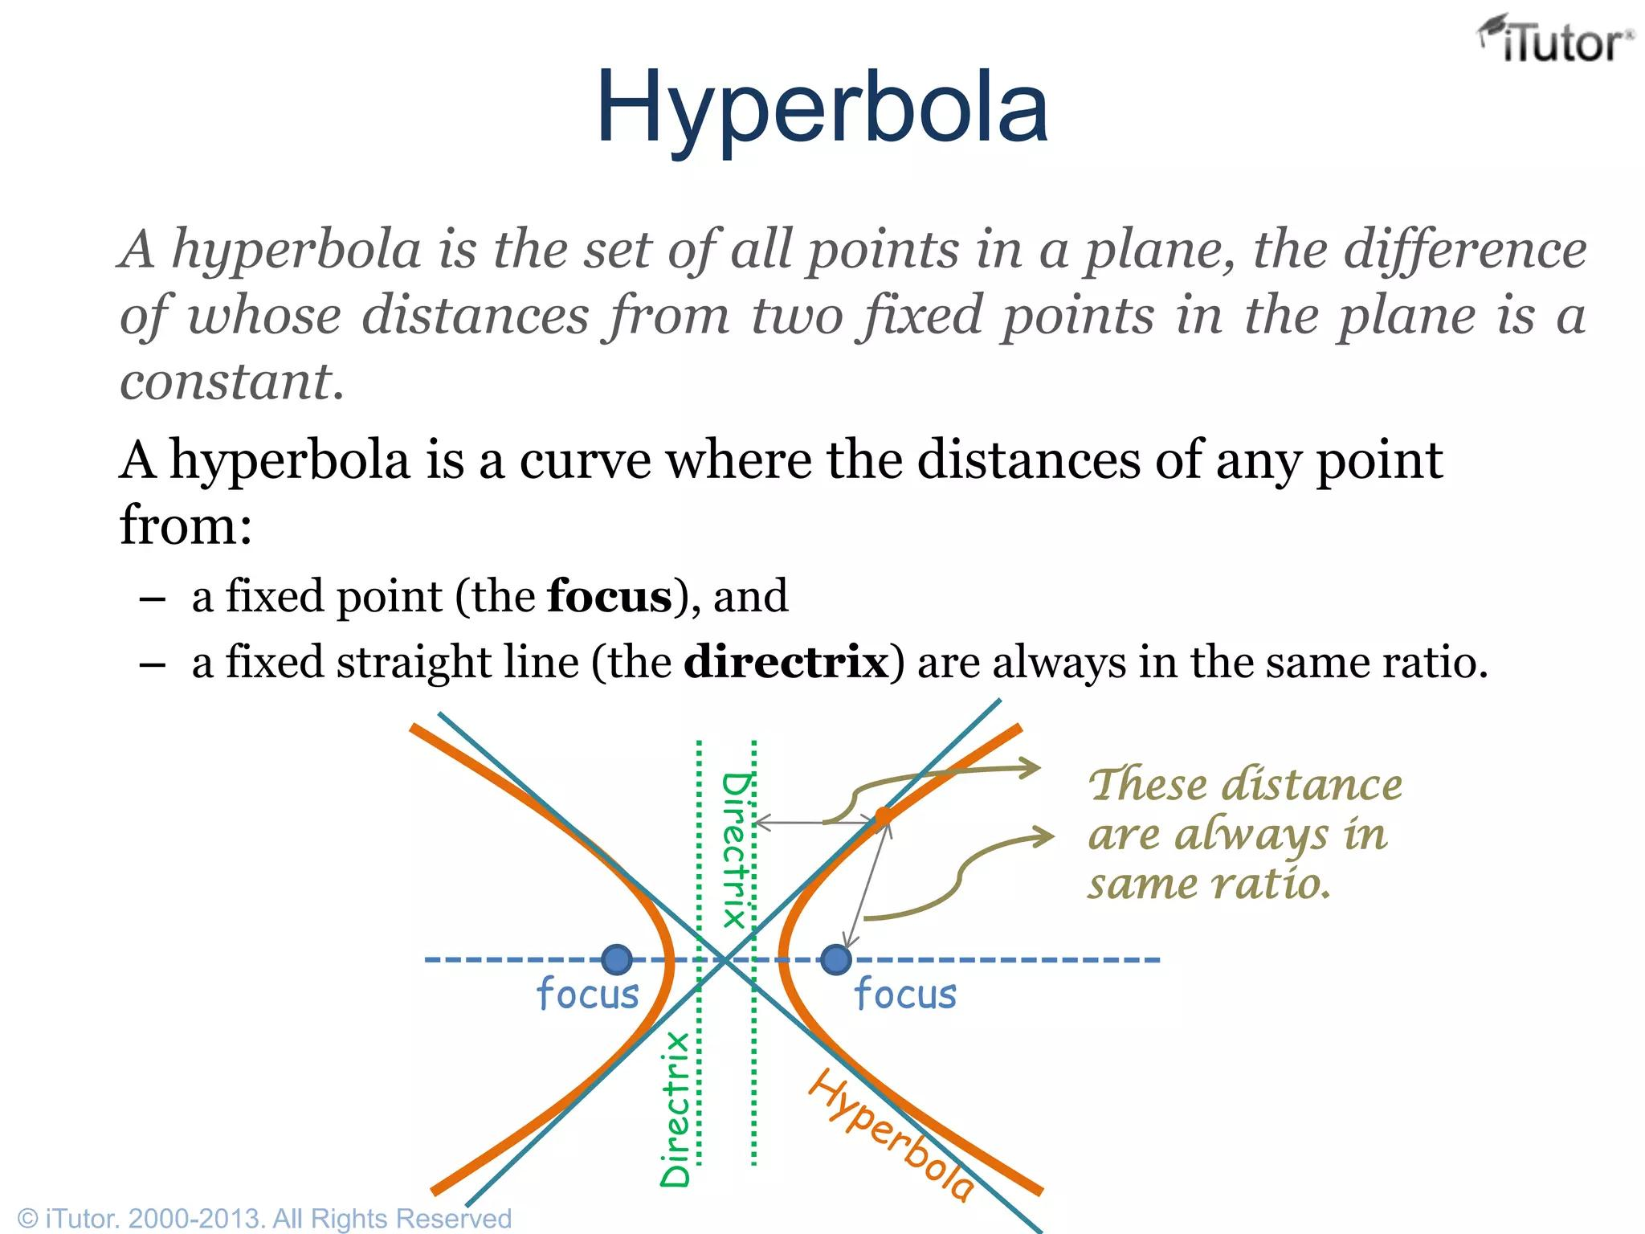
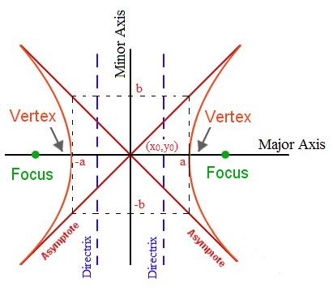
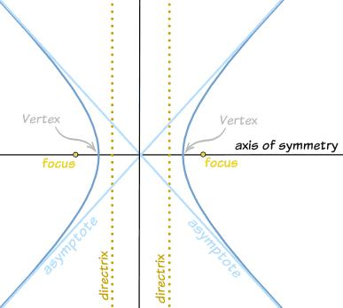
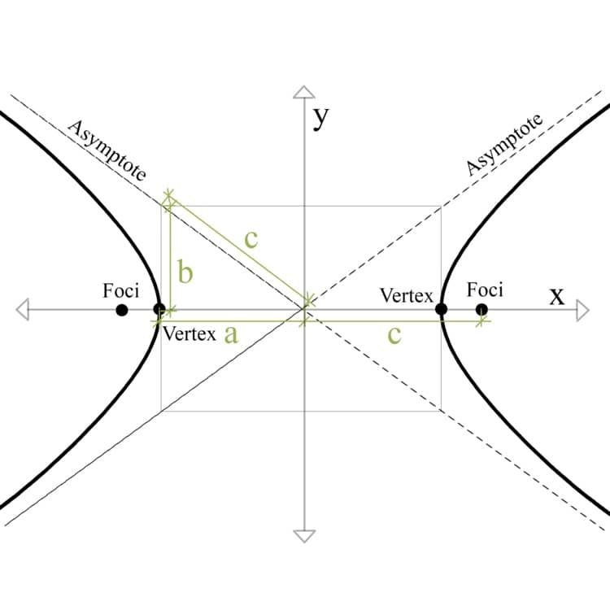
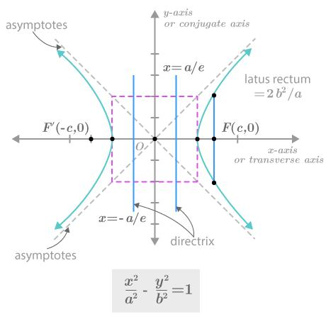
A hyperbola is obtained when a plane intersects both nappes of the double cone.
It consists of two separate branches.
It can be defined using two fixed points called foci: the absolute difference between the distances from any point on the hyperbola to the two foci is constant.
Standard equation
For a horizontally oriented hyperbola:
$$\boxed{\frac{{\left(x-h\right)}^{2}}{a^{2}}-\frac{{\left(y-k\right)}^{2}}{b^{2}}=1}$$
Eccentricity
$$\boxed{e>1}$$

Eccentricity Classification
# Source: AI Source: Provided by: [Data Path: Persons Table -> ID Column: 1, Name_En Column: Motasem Essam] -> From: [ChatGPT] on [7/25/2026]
Eccentricity provides another way to classify conic sections.
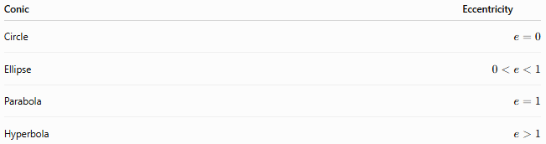
Conic | Eccentricity
Circle | $$e=0$$
Ellipse | $$0<e<1$$
Parabola | $$e=1$$
Hyperbola | $$e>1$$
This gives the fundamental classification:
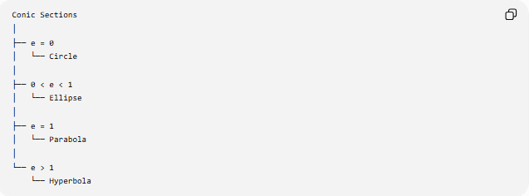
Conic Sections
│
├── e = 0
│ └── Circle
│
├── 0 < e < 1
│ └── Ellipse
│
├── e = 1
│ └── Parabola
│
└── e > 1
└── Hyperbola

Focus–Directrix Definition
# Source: AI Source: Provided by: [Data Path: Persons Table -> ID Column: 1, Name_En Column: Motasem Essam] -> From: [ChatGPT] on [7/25/2026]
A conic can be defined using a focus and a directrix.
For any point $P$on the conic:
$$\boxed{\frac{\text{Distance from }P\text{ to focus}}{\text{Distance from }P\text{ to directrix}}=e}$$
The value of $e$determines the type of conic.

Comparison
# Source: AI Source: Provided by: [Data Path: Persons Table -> ID Column: 1, Name_En Column: Motasem Essam] -> From: [ChatGPT] on [7/25/2026]
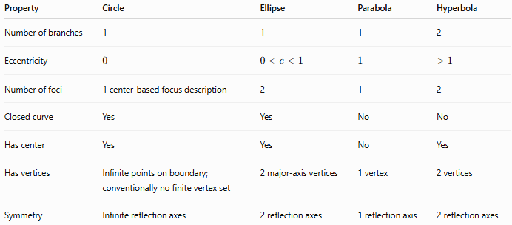
Property | Circle | Ellipse | Parabola | Hyperbola
Number of branches | 1 | 1 | 1 | 2
Eccentricity | $$0$$ | $$0<e<1$$ | $$1$$ | $$>1$$
Number of foci | 1 center-based focus description | 2 | 1 | 2
Closed curve | Yes | Yes | No | No
Has center | Yes | Yes | No | Yes
Has vertices | Infinite points on boundary; conventionally no finite vertex set | 2 major-axis vertices | 1 vertex | 2 vertices
Symmetry | Infinite reflection axes | 2 reflection axes | 1 reflection axis | 2 reflection axes

Conic Sections from a Cone
# Source: AI Source: Provided by: [Data Path: Persons Table -> ID Column: 1, Name_En Column: Motasem Essam] -> From: [ChatGPT] on [7/25/2026]
The four principal cases can be visualized as:
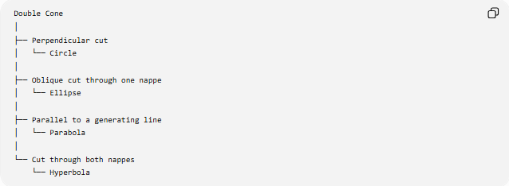
Double Cone
│
├── Perpendicular cut
│ └── Circle
│
├── Oblique cut through one nappe
│ └── Ellipse
│
├── Parallel to a generating line
│ └── Parabola
│
└── Cut through both nappes
└── Hyperbola

Degenerate Conic Sections
# Source: AI Source: Provided by: [Data Path: Persons Table -> ID Column: 1, Name_En Column: Motasem Essam] -> From: [ChatGPT] on [7/25/2026]
A conic becomes degenerate when the cutting plane passes through the vertex of the cone.
Possible results include:
Point
$$\boxed{\text{Point}}$$
Pair of Intersecting Lines
$$\boxed{\text{Two intersecting lines}}$$
Pair of Parallel Lines
This can arise as a limiting/degenerate case in the appropriate affine treatment.
Coincident Lines
Two lines can coincide in a more algebraically degenerate case.

General Quadratic Equation
# Source: AI Source: Provided by: [Data Path: Persons Table -> ID Column: 1, Name_En Column: Motasem Essam] -> From: [ChatGPT] on [7/25/2026]
In Cartesian coordinates, a conic can generally be represented by:
$$\boxed{Ax^{2}+Bxy+Cy^{2}+Dx+Ey+F=0}$$
The quadratic terms determine much of the conic's classification.
A useful discriminant is:
$$\boxed{B^{2}-4AC}$$
For the standard non-degenerate cases:
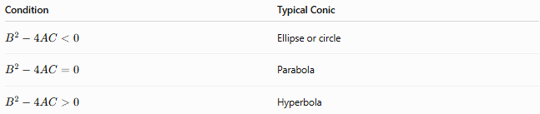
Condition | Typical Conic
$$B^{2}-4AC<0$$ | Ellipse or circle
$$B^{2}-4AC=0$$ | Parabola
$$B^{2}-4AC>0$$ | Hyperbola
Degenerate cases require additional analysis.

Applications
# Source: AI Source: Provided by: [Data Path: Persons Table -> ID Column: 1, Name_En Column: Motasem Essam] -> From: [ChatGPT] on [7/25/2026]
Conic sections occur in many areas:
- Astronomy — planetary and satellite orbits
- Physics — projectile motion and reflection
- Engineering — optical and acoustic reflectors
- Architecture — arches and structural forms
- Optics — mirrors and lenses
- Navigation — positioning and ranging
- Computer graphics — curves and geometric modeling
- Mechanical engineering — motion and trajectory analysis

Key Points
# Source: AI Source: Provided by: [Data Path: Persons Table -> ID Column: 1, Name_En Column: Motasem Essam] -> From: [ChatGPT] on [7/25/2026]
- Conic sections are produced by intersecting a plane with a cone.
- The four fundamental non-degenerate conics are:
  - Circle
  - Ellipse
  - Parabola
  - Hyperbola
- Eccentricity provides a unified classification.
- A circle has $e=0$.
- An ellipse has $0<e<1$.
- A parabola has $e=1$.
- A hyperbola has $e>1$.
- Conics can also be described using focus and directrix.
- The general Cartesian equation is a second-degree equation in $x$and $y$.
- Conic sections are fundamental objects in both geometry and algebra.

Conclusion
# Source: AI Source: Provided by: [Data Path: Persons Table -> ID Column: 1, Name_En Column: Motasem Essam] -> From: [ChatGPT] on [7/25/2026]
Conic Sections form a major family of curves generated by the intersection of a plane and a cone. The four fundamental types—circle, ellipse, parabola, and hyperbola—are unified by their eccentricity, geometric construction, and quadratic equations.

